Business Specification
API (BULK) Invoice payments

1. Version history
Version Number | Date | Author/Owner | Description of Change
7 | 15/02/2024 | Plamen Maynalovski

2. Document Review
Name | Position | Approved | Date
Thomas Butler | International commercial director
Evgeni Georgiev | Web dev team lead
Nikolay Nikolov | Web dev senior developer
Svetozar Batoev | CRM dev team lead

Contents
1. Version history 1
2. Document Review 1
3. Introduction 3
4. Goal and Objective. 3
5. Solution overview 4
6. Scope 4
7. useR Story 5
8. Use cases 5
9. Current behavior 6
10. Money and process FLOW 7
11. Future Behaviour IN API/WEB 9
12. Future Behaviour IN TM EDU CRM 12
13. Comply advantage requirements 15
14. NON-FUNCTIONAL REQUIREMENTS 16
15. RISK Assessment 16
16. Screenshots and Supportive documents 17

3. Introduction
The need for API functionality that allows agencies to pay universities/institutions via invoice number has arisen(B2B). The current API is designed for students to pay to universities/institutions and requires different data (C2B). The current API expects student information and payer information for the payment to proceed. The new functionality won’t require student data.

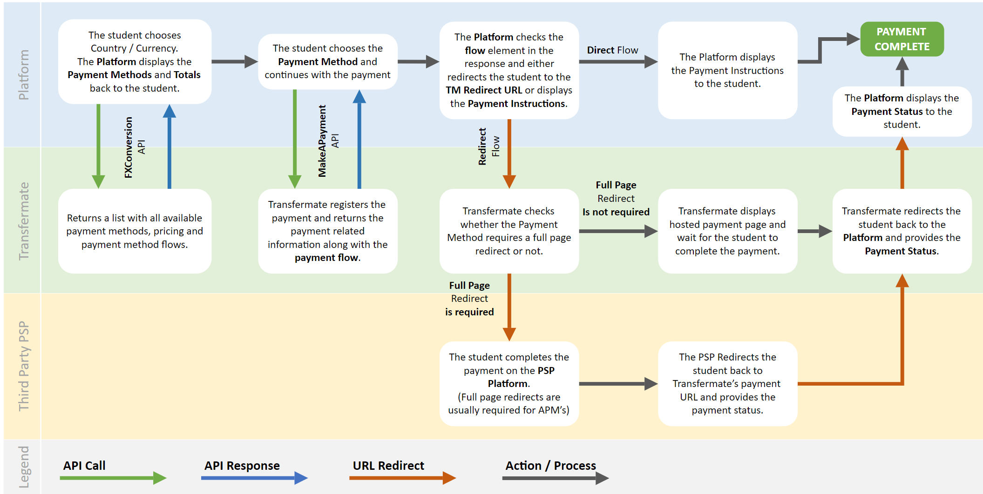

4. Goal and Objective.
4.1 To create a solution that allows agencies to pay universities/institutions with invoice numbers.

4.2 Change the logic of the currency selection: if TM does not have a bank account in the country from which the payment is made, set the beneficiary currency to local currency.

4.3 To exclude payment processors that request student information for the payment to proceed. (Only for invoice payments).

4.4 To be able to set a different margin for every agency. The default margin will be 1.2%.

4.5 Only bank transfer payment methods are to be available when paying invoices.

4.6 TM EDU CRM: API invoice payers must be accessed through the TM EDU CRM APP. The API Invoice payment must be recognized as different from the current API (Student) payments.

5. Solution Overview
- A new API functionality will be developed that allows users to pay only with invoice numbers.
- Only printable ASCII symbols will be allowed for names and addresses.
- No student information will be needed.
- Only bank transfers will be allowed.
- Invoice number will be required for payment.
- Only one invoice can be paid at a time.
- B2B payments only.
- Every agency will be able to have a different margin. Default margin 1.2%.
- API accounts will be created only for the Partners (Transact model).
- Refund functionality won’t work at the first stage of the project.
- TM EDU CRM APP: One CRM file of the beneficiary (university/institution) will be used in the TM EDU CRM APP to receive all transactions from all API partners (old and new). The API partners can be differentiated by the link ID of the transaction.
- TM EDU CRM APP: More than one partner can be selected in the CRM file in the referral field in the Agents section.
- TM EDU CRM APP: A file will be created for every agency.
- TM EDU CRM APP: The agencies will be able to be accessed by clicking the “Student” button at the transaction line in the university/institution file. The column “Student” at the grid will be renamed “Student/Agency”.
- TM EDU CRM APP: A New API invoice payer search button will be created in the Agent`s tab with the ability to search API invoice payers.

6. Scope
IN SCOPE:
- API
- WEB DB
- CRM DB
- TM EDU CRM APP

OUT OF SCOPE:
- College links
- Transfermateeducation.com

7. useR Story
As an agency
I want to use the invoice number
So that I can pay to university/institution

8. Use cases
Name: | API Invoice Payment
Goal: | The payer is to receive payment instructions.  Transaction data is to be received in the WEB DB.
Trigger (optional): | The payer logs in to the partner system.
Primary Actor: | The payer
Preconditions: | The beneficiary data needs to be created in the WEB and CRM DB.  CRM FILE must be created in the agent’s part for the university/institution.  The university/beneficiary must be onboarded, and AML checked.
Postconditions: | Beneficiary data must be received.  The invoice number must be received.  Peyer information must be received.  Booking information must be received.
Special Requirements (optional): | Related non-functional requirements.
Main Success Scenario:
Beneficiary exists in our DB.
Peyer Country is supported (Existing bank account in the chosen country).
Payer information and invoice number are received.
A bank transfer is used as a payment method.
The transaction is received in our DB.
The agent received the booking information/banking information.
Alternative Scenario:
Beneficiary information exists in our DB.
Peyer country is not supported so the currency needs to be converted. (No bank account)
Payer information is received. The invoice number is received.
A bank transfer is used as a payment method.
The transaction is received in our DB.
The agent/payer received the booking information/banking information.
Failure Scenario:
Beneficiary information does not exist in our DB.
Lack of payer mandatory information. No invoice number.
The payment method is different than bank transfer.
The transaction data is not received in our DB.
The agent/payer DOES NOT receive the booking information/banking information.

9. Current behavior
  - API parameters – Student-related and payer-related parameters are mandatory.

9.2. In the current logic when TM does not have a bank account in the country from which is paying, we have exceptions that do not allow the currency of the beneficiary to be the same as the currency of the payer.

9.3 All API transactions are attached to the Agent’s part of the TM EDU CRM. The transactions are attached either to the partner or university file. Every transaction contains student and payer information. The beneficiary is pre-created in the WEB DB and transferred to the CRM.

9.4 All payment methods are available.

10. Money and process FLOW
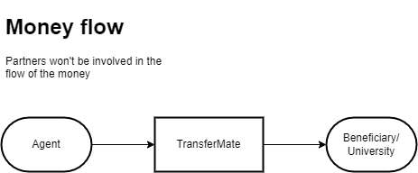

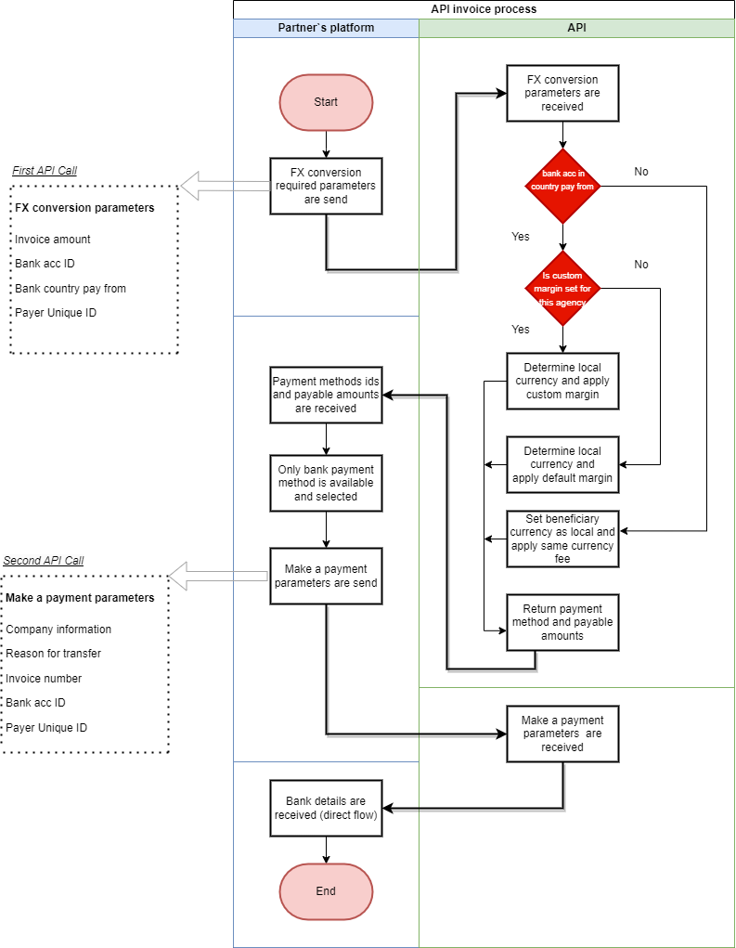

11. Future Behaviour IN API/WEB
11.1 API invoice payments will be made by agencies through the Partner’s system. Each agency needs to be able to have different margins. The default margin is 1.2%. Payer unique ID must be provided to apply custom margin (could be an email address). The combination of web login ID and agency unique ID ensures the uniqueness of the record for each partner. The payer unique ID is mandatory.

11.2 TM EDU must be able to differentiate the partner through which payment is made. API account must be created only for the partner (Transact model).

11.3 The payments will be B2B and not individual as the current API works.

11.4 FX conversion logic change: If we don’t have a bank account in the payer’s country then the amount to pay needs to convert to the base currency/beneficiary currency and the same currency fee to be added.
Payment processors that use student data must be excluded - Geoswift, Ebixcash, Dlocal

D-Local:
Indonesia
Nigeria
Argentina
Chile
Pakistan
Thailand
Bolivia
Peru
Colombia

EbixCash:
India
Geoswift:
China

Margins functionality must be redesigned so that it allows custom margins per:
1. Bank Account ID (The bank account of the school)
2. Agency unique ID (could be an email address)

11.5 FX conversion endpoint: The bank country paying from needs to be selected. Bank account ID, payer unique ID, and amount to pay need to be provided by the client.

11.6 Only bank transfer payment methods will be allowed, and no other payment methods should be allowed.

11.7 The beneficiary needs to be pre-created in the WEB DB and then sent to the CRM DB. Bank account ID must be provided to the partners. Every incoming transaction registration needs to have a bank account ID. Beneficiary information will be provided when the university/institution is onboarded. /As the current process of adding beneficiaries works/.

11.8 When collecting beneficiary information, the beneficiary's legal name must be added as the payee's name.

11.9 Make a payment endpoint: Student-related parameters must be removed from the “Make a Payment” endpoint for Invoice API payments. In this case, the company is the payer. Expected parameters:
- Invoice number – free text
- Reason for transfer – free text
- Corporate parameters:
Parameters | Format | Max Char. Length
Company legal name | Free text | 255
Company country (could be different than bank country) | Country code (ISO 3166-1 alpha-2 code). | 2
Company number | Free text (Mandatory for Brazilian payers) https://www.fonoa.com/blog/tax-number-formats-around-the-world | 50
Company postcode | Free text | 50
Company city | Free text | 50
Company address | Free text | 255
Company phone | Numbers + allowed special characters.  Special Characters: +  Example: +12062441475 | 50
Company email | Validated as email | 100

No symbols other than ASCII printable characters (character code 32-127) are allowed for all fields in the table above.

11.10 Bank details, amount to be paid, and currency must be provided to the payer in order to complete the transfer. (All necessary information for proceeding with the payment as with the current process)

11.11 API invoice payments need to be differentiated from the current API student payments.

11.12 Refunds for API invoice payments should be suspended until further notice.

11.13 Payment history endpoint:
Parameters to be removed:
All student-related information must be deleted. In API Invoice payments payer is the company.
Search parameters to be added (filter by):
- Company name
- Invoice number
- Bank account ID
- Payer unique ID

Same fields need to be provided in the API payment history response.

11.14 Webhooks and auto generated emails: All student related information must be deleted in relation to API invoice payments.

11.15 Reference number logic: Reference number will be generated by new logic – “Domain name”+”invoice number”

12. Future Behaviour IN TM EDU CRM

12.1 API Invoice payments must be recognized as different from current API payments in TM EDU CRM APP.

12.2 API invoice payments will contain only payer and not student information which makes them different than the usual API payments.

12.3 The transaction registration will be received at the “Agent” part of the CRM. Transactions will be able to be attached as usual by pressing the “ISPS Agent” button at the TM EDU CRM interface “Agent Search” tab.

12.4 Every university/institution needs to have its file and transactions to be attached to it.

12.5 A window must be created for the API Payer, as for the Student Agent. The CRM window needs to share the same functionalities as the students. It must be called “API Invoice Payers”. All transactions done by the same agency need to be visible. Every agency needs to have a unique ID (A unique ID in the CRM different than the one that will come with the transaction). Check if the agency already exists as a payer and if so, use the same ID/file. Check criteria: “Web login ID”_”Payer unique ID” and “email”. The file needs to contain:
- Corporate information: corporate name, corporate country, corporate number, address, city, postcode, phone, email
- All transactions that are made from this agency.
- List of universities/institutions that the agency is paid to. Ability to access the university/institution CRM file from the Agency file.
- Payer unique ID

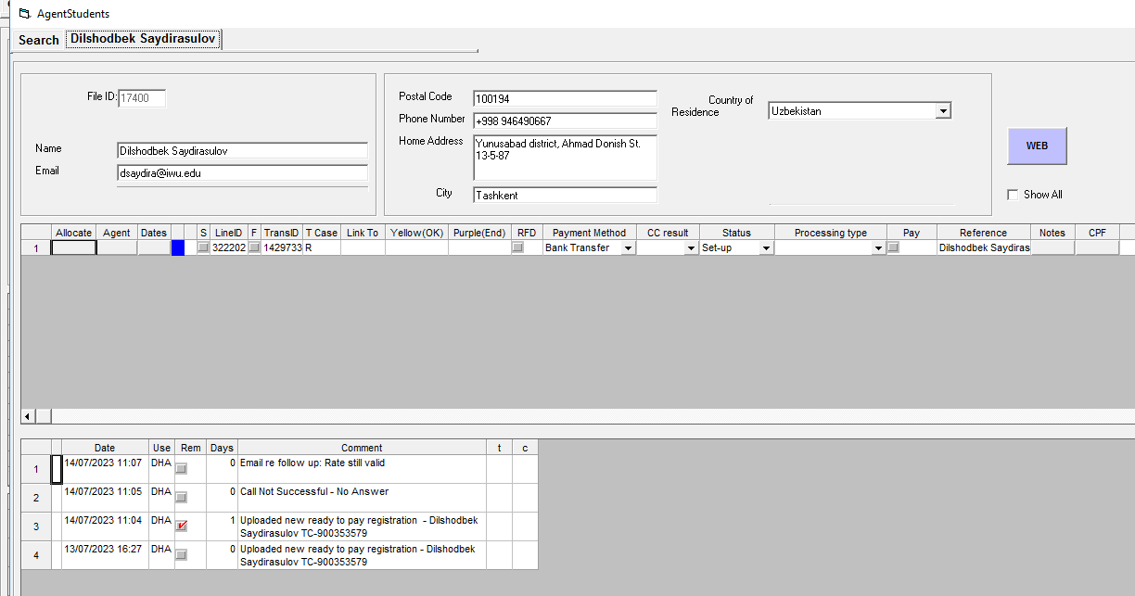

12.5 The button must be added in TM EDU CRM APP next to the "Student" button in the agent's CRM files with the column name “Payers”. When the button is clicked, the payer file must be opened.
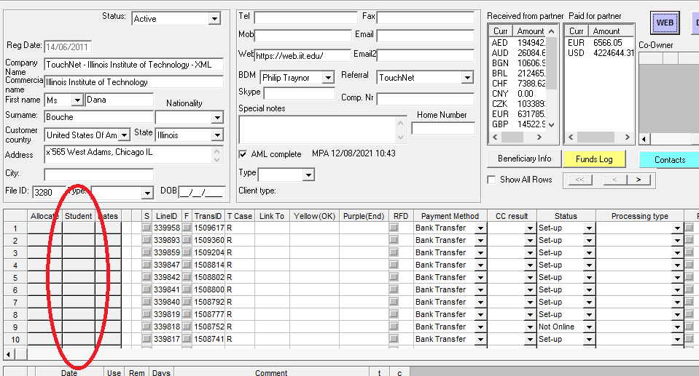

12.6 A new button “Invoice payers” must be created in TM EDU Interface at Agent`s tab.
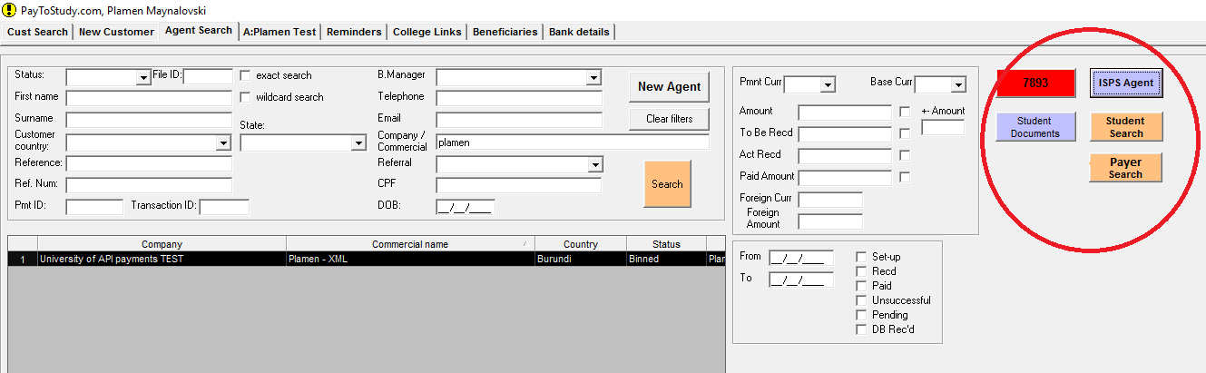

12.7 From the “Invoice payers” button, the users need to be able to search API invoice payers with the criteria: Payer unique ID, Agency ID, corporate name, corporate number, corporate country, email, phone number.

12.8 The Payer name should be filled in ttpp.name_of_payer field which is read by Corp CRM.

12.9 University/institution files will be created in the process of onboarding as the current process works. Bank details/information will be held in the same place as with the current API (students) functionality.

12.10 A new column must be added in the “ISPS Agent” window with the name of the beneficiary(sf.t_beneficiaries_banks_details. Payee_name).

12.11 When clicking the “Check” button in the “ISPS Agent” window in the case of API transactions, the beneficiary’s name must be sent to the “Company/Commercial” field in the “Agent Search” tab.

12.12 The referral field in TM EDU CRM APP in the Agents section needs to be changed to allow more than one partner to be selected.

13. Comply advantage requirements
13.1 Necessary data from the CA perspective. Universities need to be onboarded.
Customer – University/Beneficiary/Institution
Third-party profile – Agency

CA Rule sandbox Naming and Order | Attribute NAME | Parameters
Transaction Data | Transaction Data
tx_id | Transaction ID
tx_datetime | Transaction Datetime
tx_d_am_sent | Domestic ammount to send
tx_d_curr | Domestic currency
tx_transaction_status | Transaction status
tx_d_am_recd | Domestic ammount received
tx_f_am_sent | Foreign ammount to send
tx_f_curr | Foreign currency
tx_payment_reference | Payment reference
tx_reg_type | Registration type
tx_funding_method | Lodgement Type
tx_transfer_case | Transfer case
tx_main_transaction | Main_transaction
tx_regular_case_ID | Regular case ID
Customer Profile Data | Customer Profile Data
(Client of TM Edu) | (Client of TM Edu)
customer_id | Customer ID
customer_name | Customer Name (corporate)
customer_name | Customer Firstname + Customer Lastname (Individual)
customer_trading_name | Customer trading name (corporate)
customer_aml_status | Customer AML Status
customer_last_aml_date | Customer last performed AML date
customer_website | Customer website
customer_file_added_date | Customer file added date
customer_country | Customer residential country/Customer country of incorporation
customer_file_status | Customer file status
customer_registered_company_no | Customer registered company number
customer_phone | Customer phone
customer_email | Customer Email
customer_bank_name | Customer bank name
customer_bank_country | Customer_bank_country
customer_bank_country_iso_code | Customer bank ISO country code
Third-party Profile Data | Third-party Profile Data
Payer`s company | Payer`s company
Third-party_id | Third-party ID | A unique ID will be created in CRM
Third-party_name | Third-party name
Third-party_country | Third-party country
Third-party_address | Third-party address
Third-party_phone | Third-party phone
Third-party_email | Third-party Email
Third-party_entity_type | Third-party entity type | Corporate
Third-party_bank_country | Third-party bank country

13.2 TransferMate terms and conditions need to be provided.

14. RISK Assessment
14.1 It is possible that false company details may be submitted through the partner`s portal in order to obtain a better margin. This could happen because we won't keep payer data in WEB DB but only in CRM DB.

14.2 If Transfermate doesn't have a bank account in the country of the university/institution, they can't be onboarded.

14.3 For reference number creation. In case when the API link is abbreviated, the logic becomes – link abbreviation + invoice number. The ref. number could easily exceed the number of characters allowed by some banks.

15. Screenshots and Supportive documents
15.1 Partner interface mockup
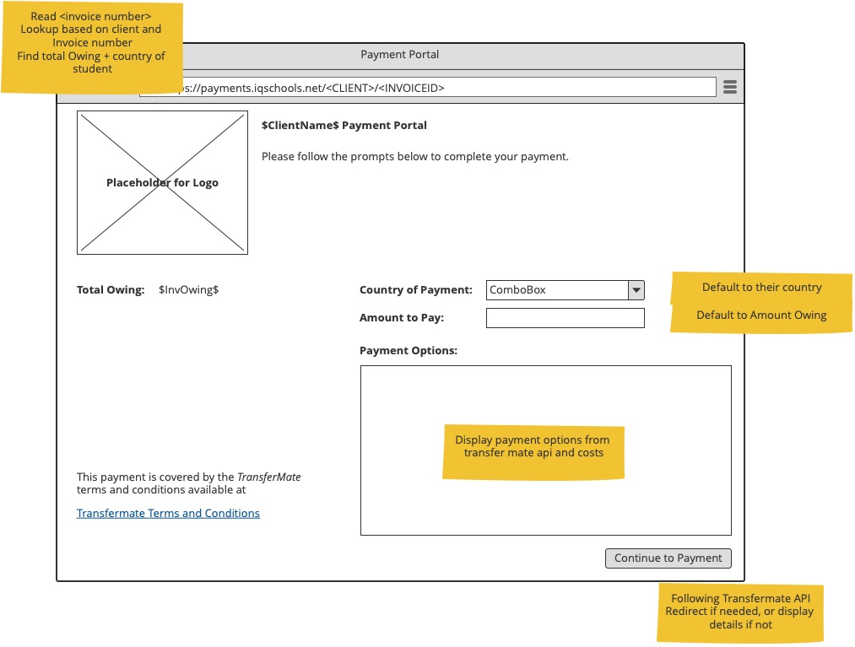
Name of Document | Date | Author/Owner | Version Number

